Name: MITHUN MARAGIRI

Course: EE450

Session #: 2

Assignment: OPNET Wireless LAN

**ABSTRACT**

The purpose of this report is to discuss the laboratory assignment for the course EE-450 Introduction to Computer Networks. The assignment is to simulate Wireless LAN environment with real-time networks and protocols. The labs have been deployed in Riverbed Modeler Academic simulation environment. The simulation in this lab will help examine the performance of Wireless LAN for Delay, Throughput, Load and Retransmission Attempts.

The assignment consists of simulation of 4 scenarios: DCF, DCF_Frag, DCF_PCF, DCF_PCF_Frag. The analysis of the experiment results are done by considering fragmentation of frames and without fragmentation of frames.

**INTRODUCTION**

Riverbed Modeler Academic Edition offers all the tools for network model design, simulation and analysis of the experiment results. Riverbed Modeler can simulate a wide variety of different networks. The laboratory has been designed to simulate Wireless Local Area Network. Through this lab, we get to learn how to use Rapid Configuration Tool for setting up wireless LAN, the different options available while setting up a network, the simulation parameters, comparing the results from different scenarios, the design of network simulation for performance evaluation.

**IMPLEMENTATION**

***Scenario 1: DCF – Distributed Co-Ordination Function***

* Create a new project and new scenario and give it a name DCF.
* Setup the initial topology and Network scale list as office network.
* From the object Palette select Wireless LAN
* Add 9 Wlan_Station_adv (fixed) from the palette.
* Set the following values for each of the 9 nodes.

|  |  |  |
| --- | --- | --- |
| **Node Number** | **Wireless LAN MAC Address** | **Destination Address** |
| Node_0 | 100 | Random |
| Node_1 | 200 | 5 |
| Node_2 | 300 | 8 |
| Node_3 | 400 | 6 |
| Node_4 | 500 | 7 |
| Node_5 | 600 | 1 |
| Node_6 | 700 | 3 |
| Node_7 | 800 | 4 |
| Node_8 | 900 | 2 |

* Set the following configuration values for all nodes except Node_0
  + Traffic Generation Parameter:
  + Start Time : Constant(2)
  + On State Time : Exponential(4)
  + Off State Time: Exponential(4)
  + Packet Generation Arguments:
  + Inter arrival time : exponential (0.06)
  + Packet Size: Uniform (500,1500)
* For each of the nodes including Node_0 set the buffer size to 4608000 bits.
* **Buffer Size:** specifies the maximum size of the higher layer data buffer in bits. Once the buffer limit is reached, the data packets arriving from the higher layer will be discarded until some packets are removed from the buffer so that the buffer has some free space to store these new packets.
* Enable Access Point Functionality for Node_0

***Scenario 2: DCF_Frag – Distributed Co-Ordination Function with Fragmentation of MAC data units.***

* Duplicate the above scenario and name it DCF_Frag.
* Select all the nodes and set Fragmentation Threshold to 256 bytes from Wireless LAN parameters.
* Enable Access Point Functionality for Node_0.

***Scenario 3: DCF_PCF – Distributed Co-Ordination Function, Point Co-Ordination Function***

* Duplicate scenario 1 – DCF and name it DCF_PCF.
* Select Nodes 0,1,3,5 and 7 and enable PCF functionality for these nodes from Wireless LAN Parameters -> PCF Parameters.
* Enable Access Point Functionality for Node_0.

***Scenario 4: DCF_PCF_Frag – Distributed Co-Ordination Function, Point Co-Ordination Function with Fragmentation.***

* Duplicate scenario 2 – DCF_Frag and name it DCF_PCF_Frag.
* Select the nodes 0,1,3,5 and 7 and enable PCF functionality attribute from Wireless LAN Parameters -> PCF Parameters.
* Enable Access Point Functionality for Node_0.

**PERFORMANCE STATISTICS**

* From Global Statistics for Wireless LAN, select Delay (sec), Load (bits/sec) and throughput (bits/sec).
* From Nodal Statistics for Wireless LAN, select Delay (Sec) and retransmission attempts (packets).

**RUNNING THE SIMULATION**

* Set the duration of the run to 10 minutes.
* Run each of the scenarios DCF, DCF_Frag, DCF_PCF, DCF_PCF_Frag one after the other.

**GRAPHS**

* **Global Statistics -> Wireless LAN -> Delay (Sec)**

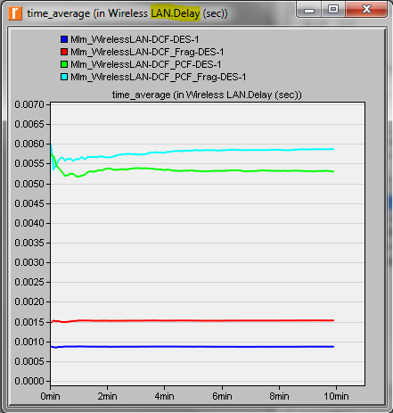

* **Global Statistics -> Wireless LAN -> Load (bits/sec)**

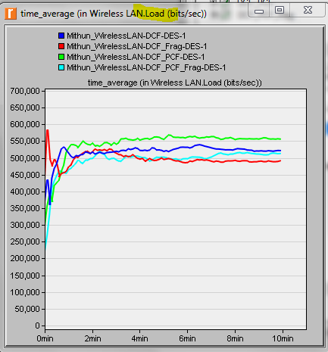

* **Global Statistics -> Wireless LAN -> Throughput (bits/sec)**

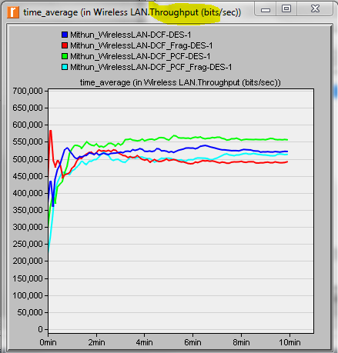

* **Object statistics -> Office Network -> Delay (sec)**

With PCF Enabled: Node_3 PCF disabled: Node_2

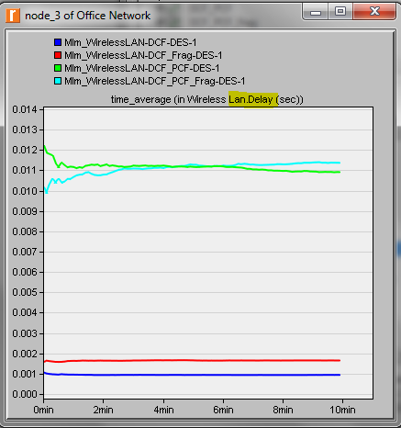 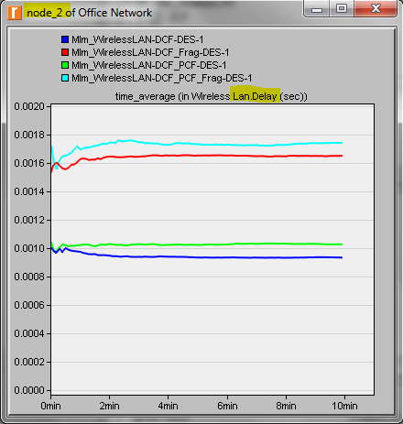

* **Object statistics -> Office Network -> Retransmission attempts (packets)**

With PCF Enabled: node_3 Without PCF: Node_2

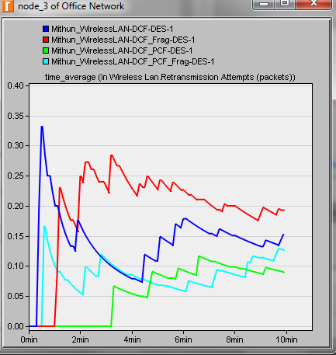 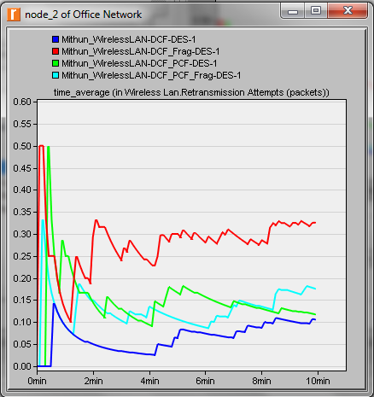

**EXERCISE**

1. Based on the definition of statistic load, explain why with PCF enabled the load is lower than if DCF is used without PCF?

Ans: Load represents the total load (in bits/sec) submitted to wireless LAN layers by all other higher layers in all WLAN nodes of the network. PCF involves polling of the wireless stations which are polling capable to check if they have any frame to send. This can avoid many retransmissions and improve the transmission efficiency.



1. Analyse the graph that compare the delay and throughput of the four scenarios. What are the effects of using PCF and fragmentation on these 2 statistics?

Ans: PCF with Fragmentation has the highest delay with this configuration. This is because the overhead is not negligible for this configuration. This is followed by PCF and then DCF_Frag.

The Scenarios which don’t have fragmentation have greater throughput than with fragmentation. Scenario with PCF and no fragmentation has highest throughput for this configuration.

 

1. From the last four graphs, explain how the performance of a node without PCF is affected by having PCF enabled in other nodes in the network?

Ans: In the graphs below, node 3 has PCF enabled and node 2 does not have it enabled. The delay is more for the scenarios where PCF is enabled and PCF Fragmentation is enabled. When PCF is not enabled the delay for the scenario where fragmentation is enabled the delay is more. This is because the payload for this configuration is not negligible

With PCF Enabled: Node_3 Without PCF enabled: Node_2

 

With PCF enabled, the retransmission number is less. However when PCF is not enabled but just fragmentation is enabled, the retransmission number is more.

Without PCF enabled case, the retransmission number is more for the cases that have fragmentation i.e DCF_Frag and DCF_PCF_Frag

With PCF enabled – Node 3 Without PCF Enabled Node 2 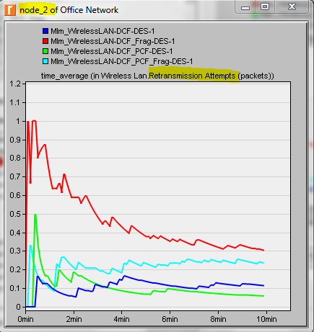

1. Create two new scenarios as duplicates of the DCF_PCF scenario. Name the first new scenario DCF_allPCF and the second new scenario DCF_twoPCF . In DCF_allPCF , enable the PCF attribute in all eight nodes: node_1 through node_8. (Note: Do not include node_0 in any of your attribute editing.) In DCF_twoPCF , disable the PCF attribute in node_3 and node_5 (this will leave only node_1 and node_7 with PCF enabled). Generate the graphs for the Delay , Load , and Throughput statistics, and explain how the number of PCF nodes might affect the performance of the wireless network

Ans: **Scenario DCF_allPCF , DCF_twoPCF**

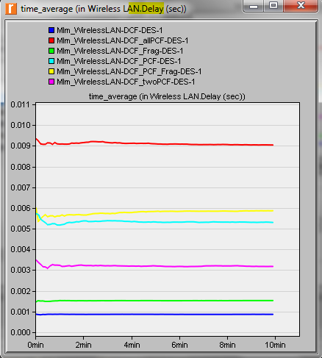 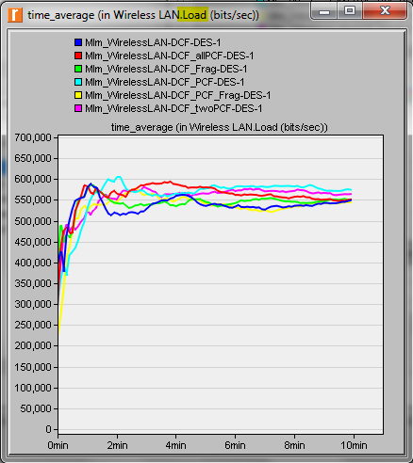

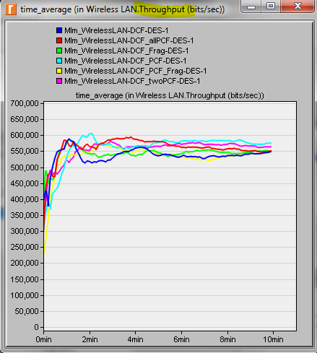

Comparing the DCF_PCF scenario with the ones which we created just now, the delay is highest when PCF is enabled for all the nodes and least when PCF is disabled. The load is almost same with DCF_PCF having the highest load. The throughput is highest for the scenarios DCF_PCF

1. For all scenarios, select the Media Access Delay statistic from the Global Statistics Wireless LAN hierarchy. Rerun the simulation for all scenarios. Generate the graph that compares the Media Access Delay statistic of all scenarios. Analyze the graph, explaining the effect of PCF, fragmentation, and number of PCF nodes on media access delay

Ans

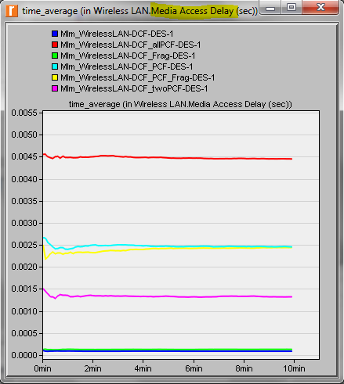

DCF scenario with PCF enabled for all nodes has the highest access delay. This is the slowest since the data has to be separated and then reassembled which will consume the most time and effort.

**RESULTS**

We have studied the 4 cases: DCF, DCF_PCF, DCF_Frag, DCF_PCF_Frag. The results shown in the screenshots throughout the report demonstrate that DCF with PCF enabled and with fragmentation has highest delay. The DCF PCF scenario has the highest throughput. The load is also the highest for DCF_PCF scenario. The delay increases if PCF is enabled. Also the delay increases if fragmentation is enabled. The retransmission attempts with PCF enabled nodes have the highest value when its DCF with fragmentation, followed by DCF scenario. Retransmission attempt without PCF has highest value for DCF with fragmentation followed by PCF fragmentation.

**Riverbed Modeler Experience**

The tool is very much user friendly and has easy to use graphical user interface. The assignment description document has detailed explanation about the configuration and the procedure for conducting the lab. The usage to the tool gave an understanding of how to set up a wireless LAN, the various components needed to setup the LAN, the performance measures for each of these scenarios. The installation of the tool is also very simple and straightforward. The tool is scalable to great extent. If we want to update the network scenario we can do it without rebuilding entire thing from scratch. OPNET modeller lets us analyze realistic simulated networks to compare the impact of different technology designs on end to end behaviour.